Suhil Abdo

Create K8s Manifest files

# Pods



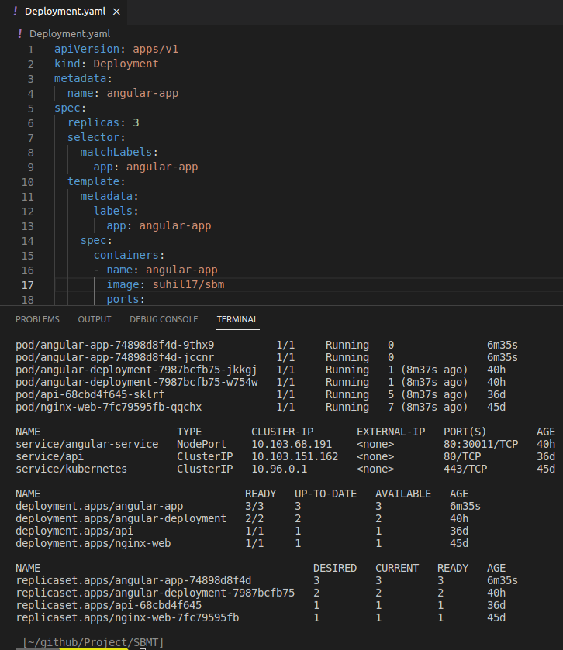

# 

# Replicasets

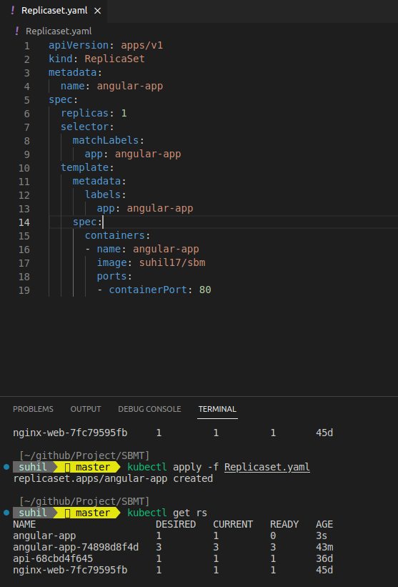

# 

# 

# Services

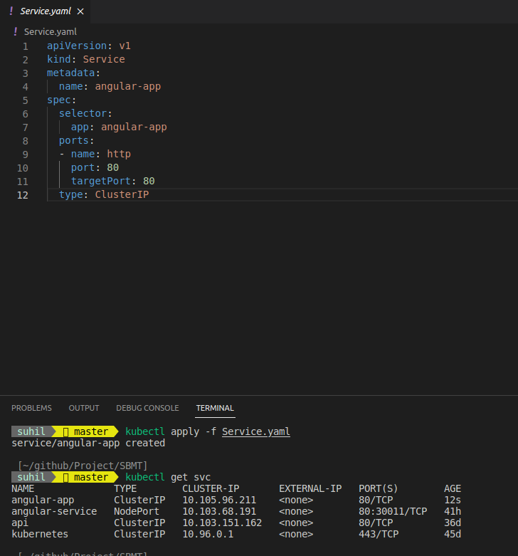

# 

# 

# 

# 

# 

# 

# Ingress

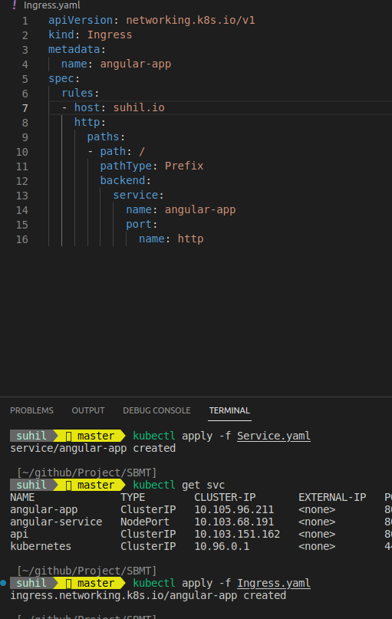

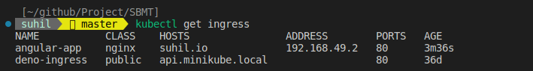

# ConfigMap

# 

# 

# Secrets

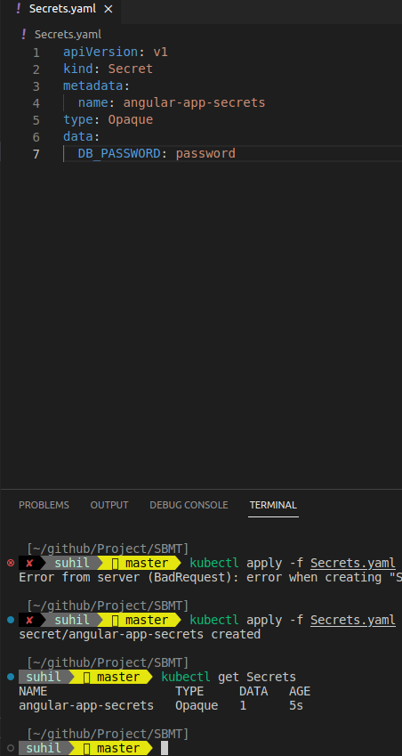

# All files

